**TimeTracker user guide**

Contents

1. General look and feel. 2

2. Special functions. 4

3. Logs 5

4. Settings 6

5. Installation 7

6. Extra info 7

1. **General look and feel.**

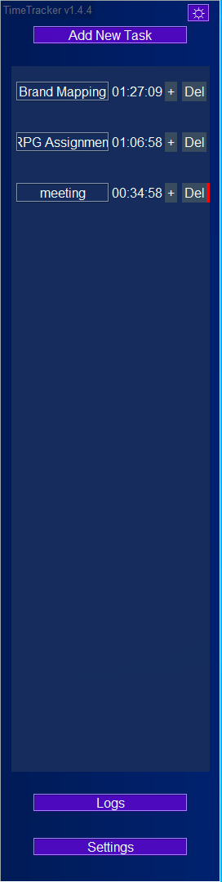1.1 The tracker opens up in the left side of the screen, hidden behind the edge. To display its window, simply move your mouse to the left edge of the monitor. When you move your mouse away from the tracker window, it will self-hide.

1.2 To close the program, press the top-right purple button.

1.3 With the “Add New Task” button, you can add up to 15 tasks on the grid. They display below.

1.4 Each task has a row of elements (from left to right):

1) Name/On-off switch

2) Accumulated time for the current day

3) Button “+” to add time manually

4) Del – delete the current task from the grid

5) Red label indicates currently activated task

1.5 To display all the tracked time for a specific day, open the “Logs” window

* 1. Settings

1. **Special functions.**

2.1 Deleting a task, removes it from the visible list, but does not purge the already accumulated time. If you want to restore a deleted task, create a new task with the same name. The accumulated time will be restored with it.

2.2 You can switch between tasks by pressing the one you want to record. The previous one will stop recording automatically (not applicable if multi-tracking (see 4.4)).

2.3 When you lock your computer, any active tasks will stop automatically.

2.4 On startup, the program always checks for new versions and prompts the user if they want to update.

2.5 The program can remain open between workdays. The timers get automatically nullified.

1. **Logs**

3.1 The Logs window shows all recorded times by task, for a chosen date.

3.2 If there are no records for a day a message will appear.

1. **Settings**

4.1 Autosave – how often to save the recorded data to file. Default value – every 20 seconds.

4.2 Checks to start the program with Windows and to create a shortcut on the desktop.

4.3 Activity reminder – get an alert to check if you’re tracking and if it’s the correct task.

Set to 0 if you don’t want alerts.

4.4 Record multiple tasks at once – activate if you want to be able to track more than 1 task at the same time.

1. **Installation**

5.1 Download the latest version: <https://infinitenex.github.io/TimeTracker/>

5.2 Unzip the file to any directory on your computer;

5.3 Start TimeTracker.exe from the extracted folder;

1. **Extra info**

6.1 Developer contacts:

[Simeon.todorov@gfk.com](mailto:Simeon.todorov@gfk.com)

Or

[the_nexus@mail.bg](mailto:the_nexus@mail.bg)

6.2 Bug reports, planned features and suggestions:

<https://github.com/InfiniteNex/TimeTracker/issues>